Ramp cat: (flag - 40,43.2257N/73,59.0405W)

I began by researching how to extra data/metadata from image files such as pngs. My research led me to this post: <https://superuser.com/questions/219642/what-software-can-i-use-to-read-png-metadata> about using ImageMagick to read the metadata of a file. After installing and running this via “identify -verbose IMG_0743.png”, I determined that there was nothing that could help me here and tried another approach.

The next thing I tried was exiftool. I installed it via “sudo apt install libimage-exiftool-perl -y” and ran “exiftool IMG_0743.png”. Based on the question asking for the location of this cat along with the hint of there being 2 components to the flag, I decided to try the latitude and longitude I received from this command. I entered this but once again it did not work.

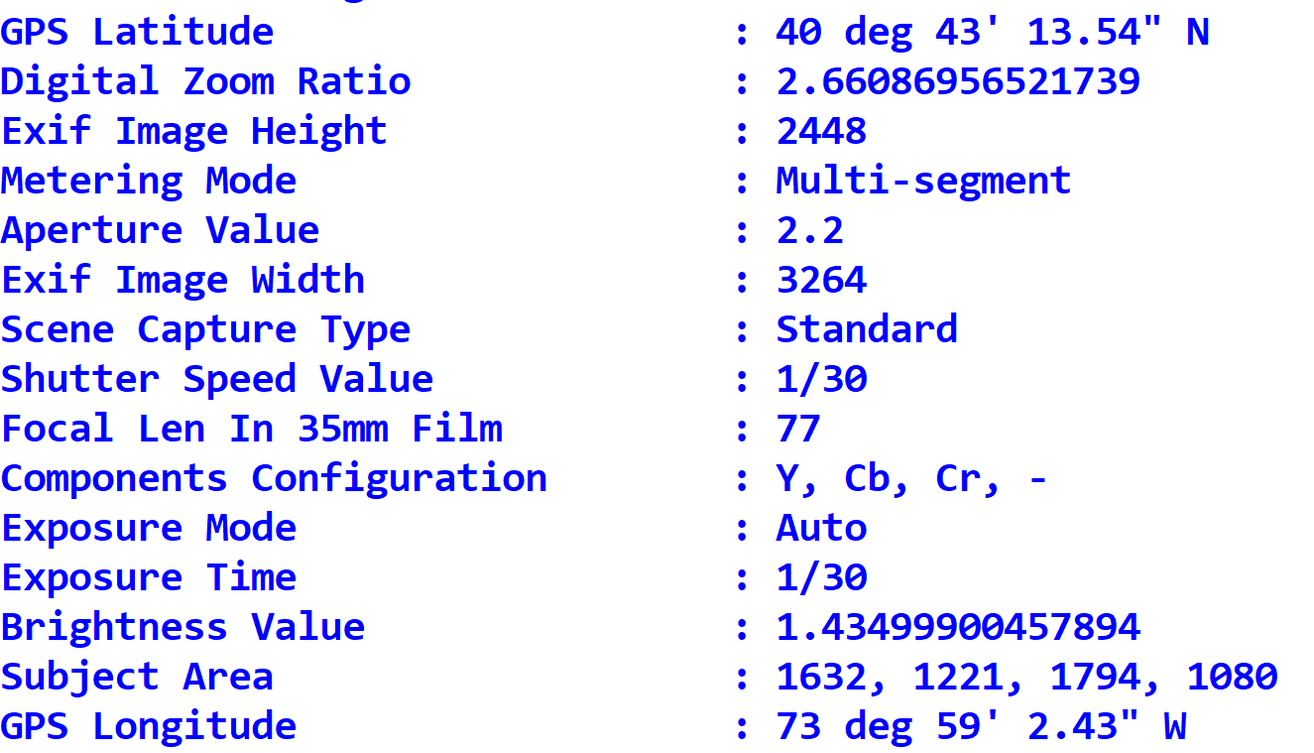

(<https://infosecwriteups.com/beginners-ctf-guide-finding-hidden-data-in-images-e3be9e34ae0d>)

Lastly, I tried to open the file in notepad++ (it simply crashed notepad) to see what I could find. I found different latitude/longitude coordinates and entered those and they were correct!

